PRESS RELEASE FOR PUBLICATION

Leonberg, 20 November 2017

33rd Stuttgart German Masters international horse show:
The Brazilian Pedro Veniss wins the 'GEZE GmbH Prize'
Olympic champion Michael Jung takes second place

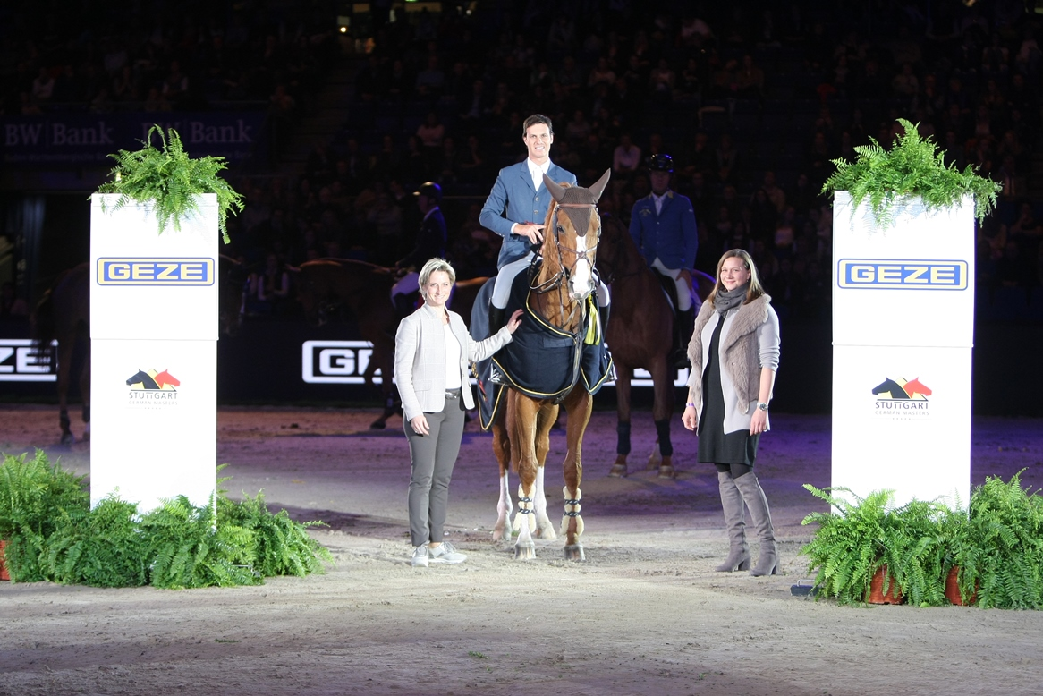

Photo: GEZE GmbH

Sandra Daniela Alber (right), shareholder of GEZE GmbH, and Baden-Württemberg's Minister of Economic Affairs and horsewoman Nicole Hoffmeister-Kraut congratulating Pedro Veniss. The winner received a horse blanket in GEZE colours and a gold coin as the prize of honour.

Pedro Veniss came first in the challenging show jumping competition and winning round on his 12-year-old Hanoverian mare For Felicila. It was a great honour not just to accept the top award and prize of honour from GEZE shareholder Sandra Daniela Alber: congratulations also came from Nicole Hoffmeister-Kraut, Baden-Württemberg's Minister of Economic Affairs, and multiple former national dressage champion and holder of the German 'Goldenes Reiterabzeichen' gold riding badge.

In the best time of 41.79 seconds with no penalty points, the Brazilian, who now lives in Europe, took the GEZE GmbH prize. The challenging category 5 (CSI 5*) show jumping competition which took place on 18 November 2017 at the Hanns-Martin-Schleyer-Halle in Stuttgart attracted 47 riders and horses to the start. Twelve horses and riders made it to the final winning round.

The 34-year-old Pedro Veniss has proven himself at the world's biggest show jumping events. At the 2016 Olympic Games in Rio de Janeiro, he finished fifth in team. At the end of 2016, he celebrated his biggest success yet as a show-jumper by winning the Rolex Grand Slam at the international equestrian competition in Geneva (Switzerland).

Michael Jung secured second place, finishing the final course 27 hundredths of a second slower on his eight-year-old Westphalian mare fischerSolution, and completing the competition without penalties in 42.06 seconds. The 35-year-old world class rider has achieved every accolade in his sporting career: He ranks number one in the world as an eventing rider, he won two medals at the London Olympics in 2012 and also took Olympic Gold at the 2016 games in Rio de Janeiro. He has twice been World Champion, and six times European Champion. He took the Grand Slam in 2016, winning tournaments at Burghley, Badminton and Lexington.

In third place was the French rider Kevin Staut on Vendome d'Anchat HDC, his eight-year-old chestnut gelding. Horse and rider also completed the circuit without penalties in 42.36 seconds. The 37-year-old is an elite horse-jumper in France. This was not his first placing in Stuttgart. The former European champion won the 2012 Stuttgart German Masters. In 2013, he took third place in the World Cup Final in Gothenburg. As part of the French team, Staut won a medal at the 2014 World Championships in Caen (Silver) and at the 2016 Olympic Games in London (Gold).

The international company GEZE GmbH, a global market leader in door, window and safety technology, has sponsored the challenging show-jumping event at the Stuttgart German Masters for many years with the 'GEZE GmbH Prize'. This major tournament is a World Cup stage in terms of show-jumping events: The biggest eventing test, the 'Grand Prix of Stuttgart', counts as a qualifier for the World Cup Final in jumping (Longines FEI World Cup Jumping), which will take place in April 2018 in Paris.

